WELCOME TO BELL FRASER LAKE LIVING

Tips and Best Practises for Healthy and Neighbourly Lakefront Living

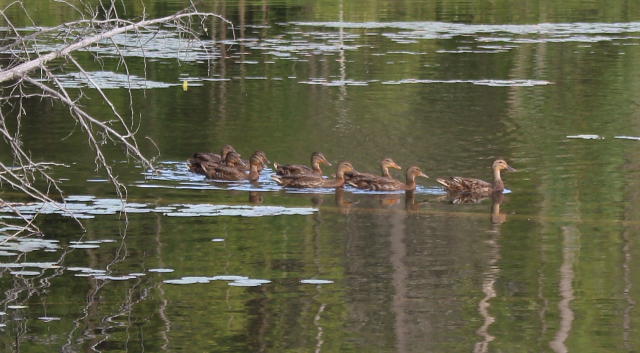
Welcome to our beautiful community, where the health of our fragile small lakes is our top priority and enjoying each other’s company a close second!
The purpose of this pamphlet is to outline best practises from a lake health environmental standpoint in order to be able to continue to swim in our clean waters and protect wildlife.
We also wish to provide you access to our website so that you can find out more local and municipal information. http://www.bellfraser.ca/
Bylaws:
Both lakes are non- motorized. Electric motors, canoes, kayaks paddle boats and stand up paddleboards, are acceptable.
ANY boats, inflatable, or paddle variety from other waterways MUST be power-washed before entering our lakes.
For a comprehensive list of bylaws, please see the municipality website. : http://www.villelapeche.qc.ca/en/municipality/by-laws-and-permits/
Most of us are here to enjoy each other and the nature that surrounds us. We ask that households observe the wishes of the majority, in our attempts to reduce the following:
Noise, Light, Air, Water and Land pollution. These may include but are not limited to:

Shoreline and water Protection Best Practises:
ENCOURAGED | DISCOURAGED
Planting of native plants & trees for shoreline protection | Using any fertilizers within 15 meters of the shoreline
Non phosphate products for cleaners, soap & dishwasher | Gardening/digging within 15 meters of the shoreline
Fire pits positioned so ashes do NOT go in lakes | Bathing in the lake with any kind of soap
Sawdust kept out of lakes | Dumping of Sand into lake
Leave the shoreline alone | Building , plowing, moving, or removing plants near the shoreline

Garbage & Recycle: Please use sealed municipal bins; so that wildlife does not scatter garbage over the road. Refrain from littering on our roadways.
Poop & Scoop: residents are asked to pick up dog waste along our trails and roads.
Digging of native species: We are encouraged to leave lady slippers, ferns, and native plants in their places. Often a transplanted wild plant will not tolerate moving and dislike its conditions in your garden.

To meet your neighbours and be heard, join our association and come to our meetings for more information.

